

**Topic: Document Subscriptions**

We all know it’s important to stay up to date with current processes and document updates. But, did you know you can make it easier by subscribing to documents? Subscriptions help keep you notified of any changes to the document by sending you alerts when the document has been updated.

**Subscribing:**

Documents can be subscribed to from the Home page or search results, as well as from within a document.

To subscribe to a document, locate the Pin icon for the document you want to add to your subscriptions.

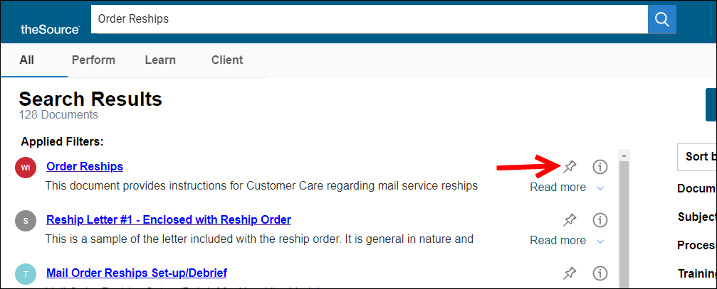

* A pop-up will display at the bottom left of the browser indicating that you’ve successfully subscribed to the document, and the Pin icon will change to gray.



**Viewing Subscription Alerts:**

When a document you have subscribed to is updated, the Pin icon at the top right of the page will display an orange circle next to it to alert you of the update.



To view your subscription Alerts, click the Pin icon in the upper right at the top of any page in theSource.

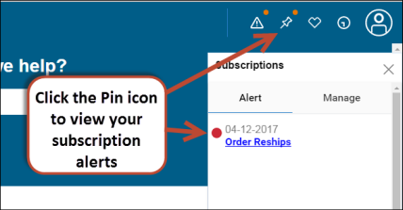

The Subscriptions window will pop-up on the right side of your browser.

The **Alert** tab shows which documents have been updated.

* Open and view a document to clear the alert from this tab.
* View all of your subscription updates to clear the alert. This way you’ll know when a new one comes in.

The **Manage** tab lists all of your subscriptions.

* Keep this tab up to date by removing any subscriptions you no longer need by clicking the trash can icon.

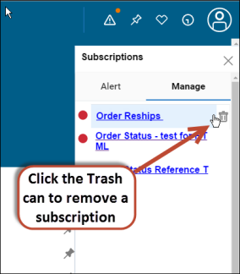

For more information, refer to [theSource- Feature User Guide](TSRC-PROD-000828).

 Your next challenge on the quest to becoming a Certified theSource Wizard is to subscribe to one or more documents you frequently access, stay up to date with any changes by viewing Subscription Alerts, and manage your subscriptions by removing those you no longer need.

Additional resources:

Become a Certified theSource Wizard: Index

Not to Be Reproduced or Disclosed to Others without Prior Written Approval

**ELECTRONIC DATA = OFFICIAL VERSION / PAPER COPY = INFORMATIONAL ONLY**